**AWS Challenge**

Launch one **EC2 instance** using **Amazon Linux 2**.

* Install **Docker**.
* Install **Jenkins**.
* Install **Apache**.
* Install **Nginx**.
* Install **Apache Tomcat**.

1. Launch one **EC2 instance** using **Amazon Linux 2**.

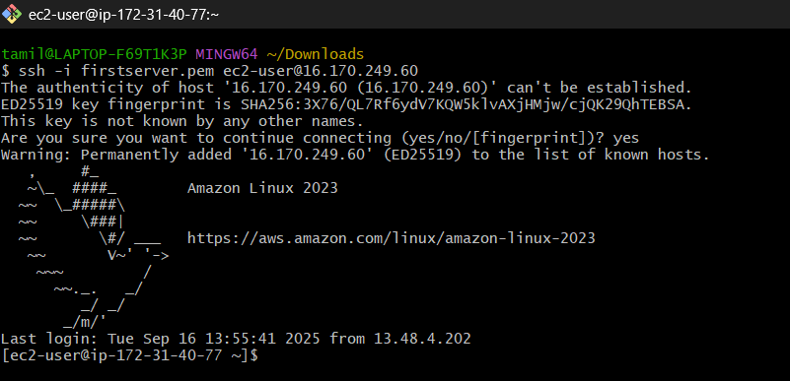

**Step 2: Update the System**

sudo yum update -y

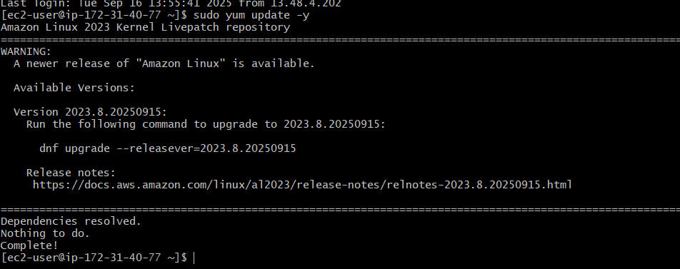

**2: Install Docker**

1. **Enable & install:**
2. **sudo yum install -y docker**

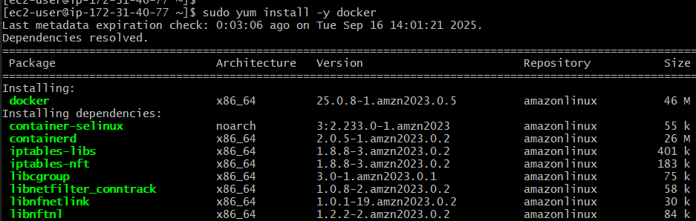



Note: You can also use the following system control command.

sudo systemctl start docker

6. Let’s check if the Docker is actaully up and running.

sudo service docker status

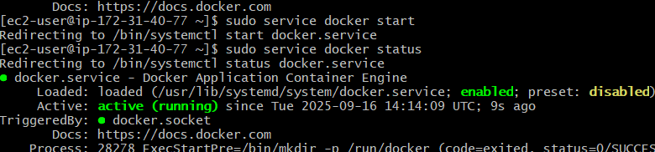

Created symlink /etc/systemd/system/multi-user.target.wants/docker.service → /usr/lib/systemd/system/docker.service.

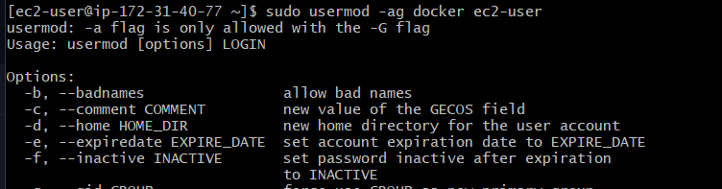

Use this command for checking the version: “ docker –version”

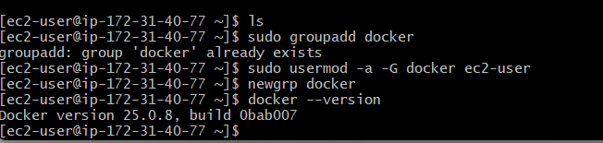

. If you want to see an extended version of the version details, such as the API version, Go version, and Engine Version, use the version command without dashes.

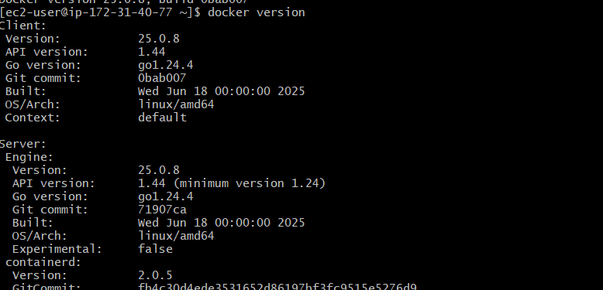

* 1. Install **Jenkins**.
* sudo yum update –y

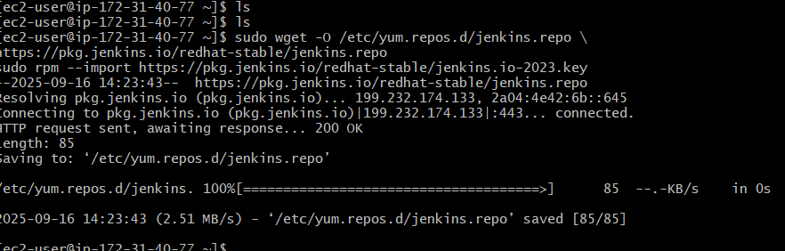

sudo yum install java-21-amazon-corretto -y

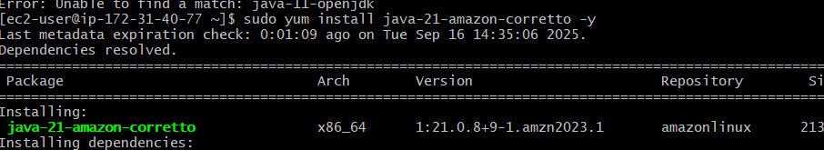

sudo yum install jenkins -y

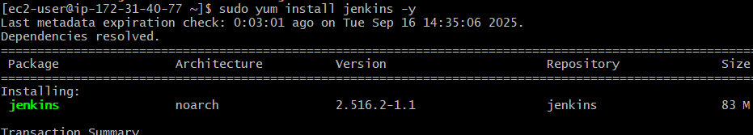

sudo systemctl enable jenkins

Created symlink /etc/systemd/system/multi-user.target.wants/jenkins.service → /usr/lib/systemd/system/jenkins.service.

Enable the Jenkins service to start at boot:



Start Jenkins as a service:

sudo systemctl start jenkins

You can check the status of the Jenkins service using the command:

sudo systemctl status jenkins

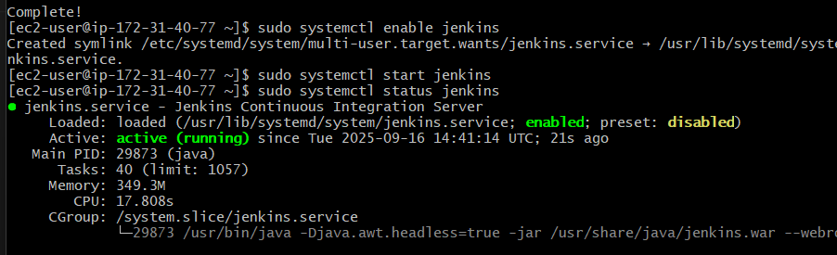

**Configuring Jenkins**

Jenkins is now installed and running on your EC2 instance. To configure Jenkins:

1. Connect to http://<your_server_public_DNS>:8080 from your browser. You will be able to access Jenkins through its management interface:

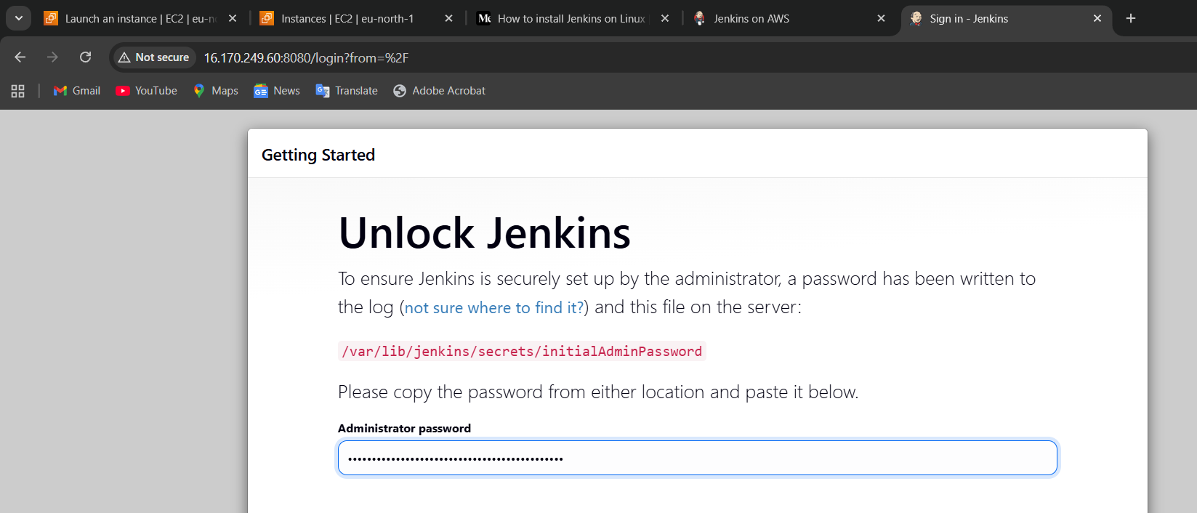

As prompted, enter the password found in **/var/lib/jenkins/secrets/initialAdminPassword**.

1. Use the following command to display this password:
2. Jenkins runs on port 8080 by default. Access Jenkins through your web browser by entering http://your_server_ip:8080. You should see a screen asking for an initial administrator password.



Enter the password to access

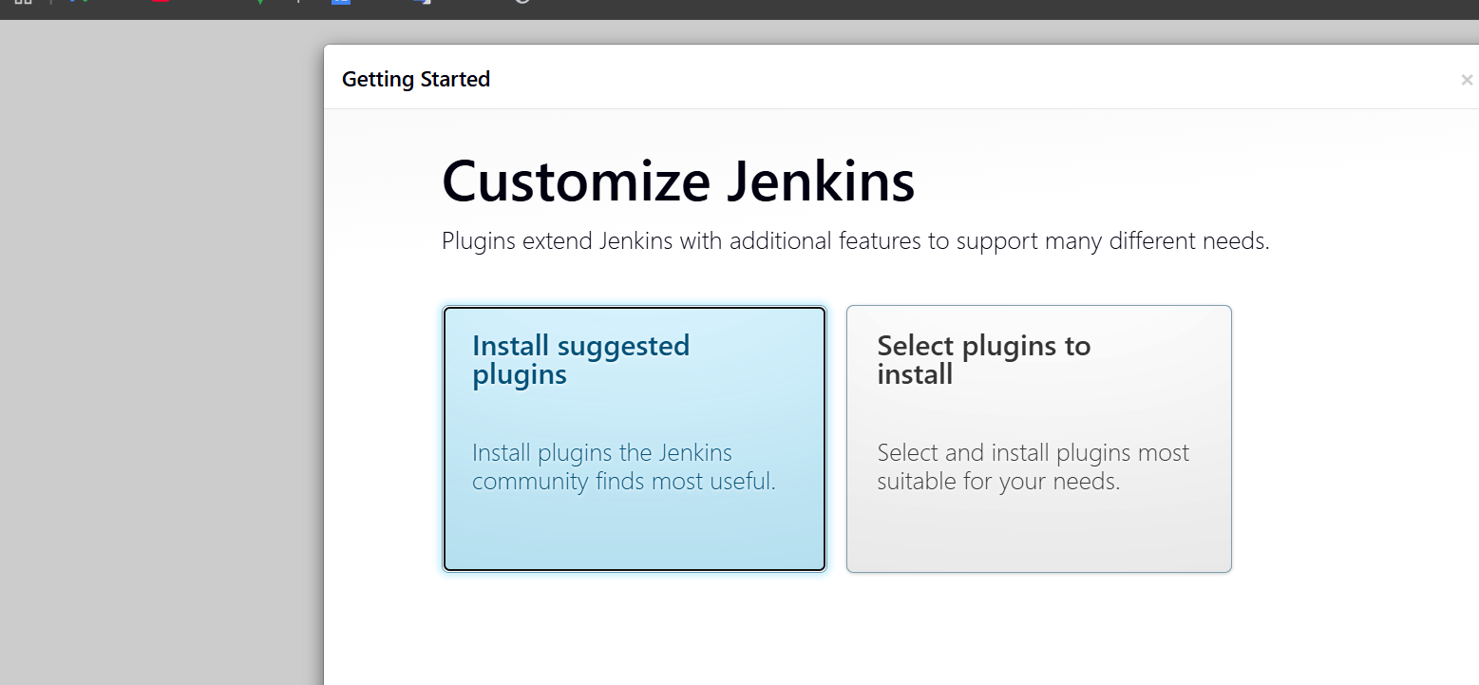

<http://16.170.249.60:8080/user/admin/=>> used to access my Jenkins

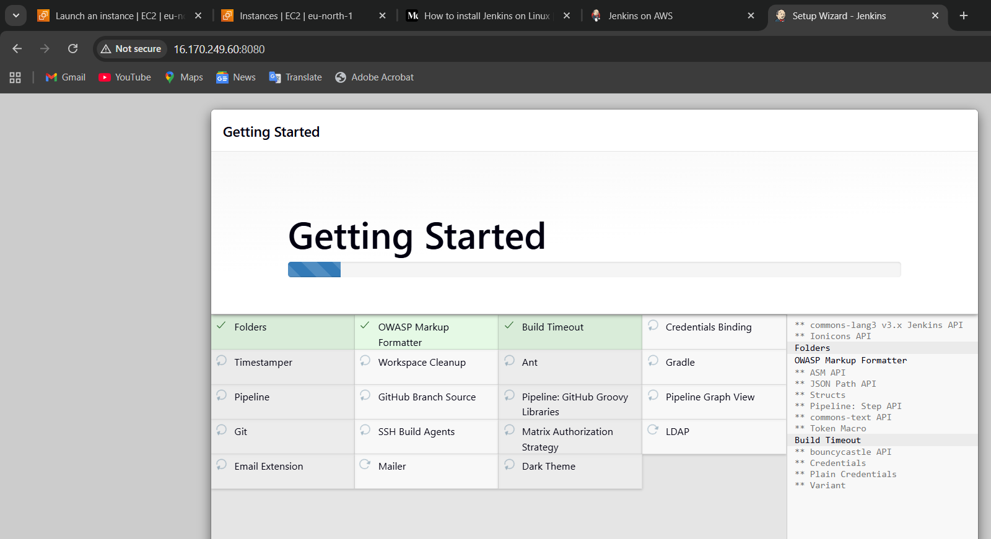

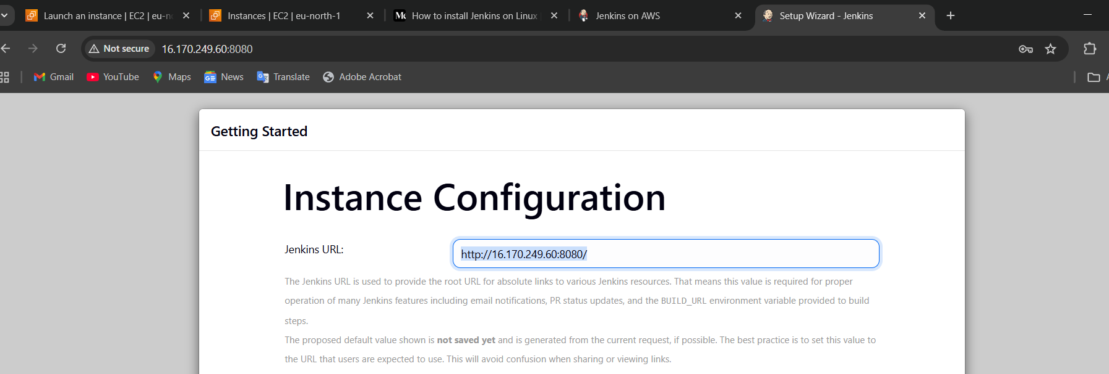

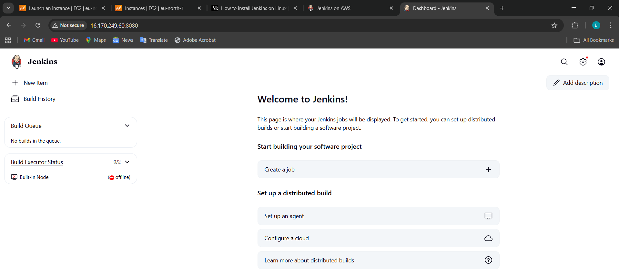

1. Install **Apache**.

Install Apache (httpd) (on port **80**)

sudo yum install -y httpd

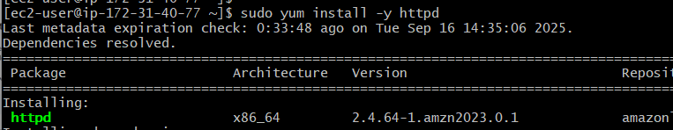

sudo systemctl start httpd

sudo systemctl status httpd

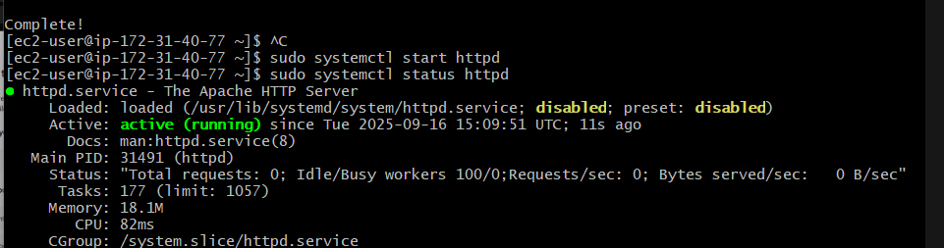

Copy ip address past (ip:80)

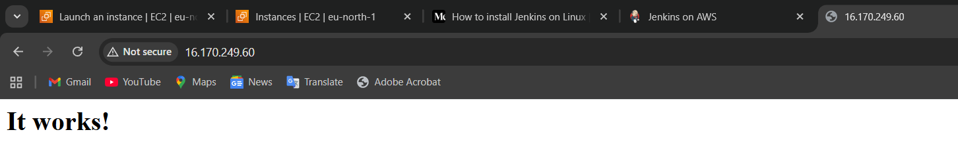

sudo vi /etc/httpd/conf/httpd.conf => oopen this file edit change 80 to 81 save and exit

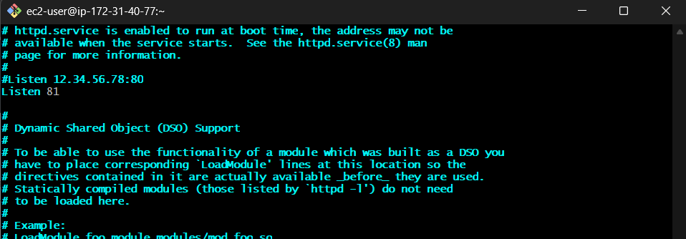

sudo systemctl restart httpd

sudo systemctl status httpd

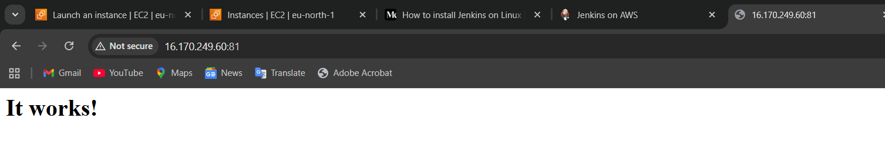

4 ) Install **NGINX**.

**Step 1: Update System**

sudo yum update -y

sudo yum install -y nginx

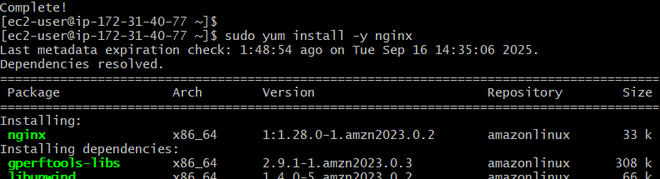

sudo systemctl start nginx

sudo systemctl status nginx to check the status of whether is active on or of

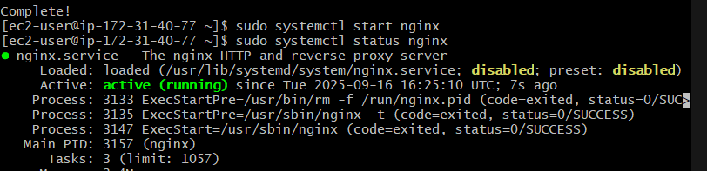

systemctl status nginx

Paste (IP:80)address in the website, IT WILL SHOW

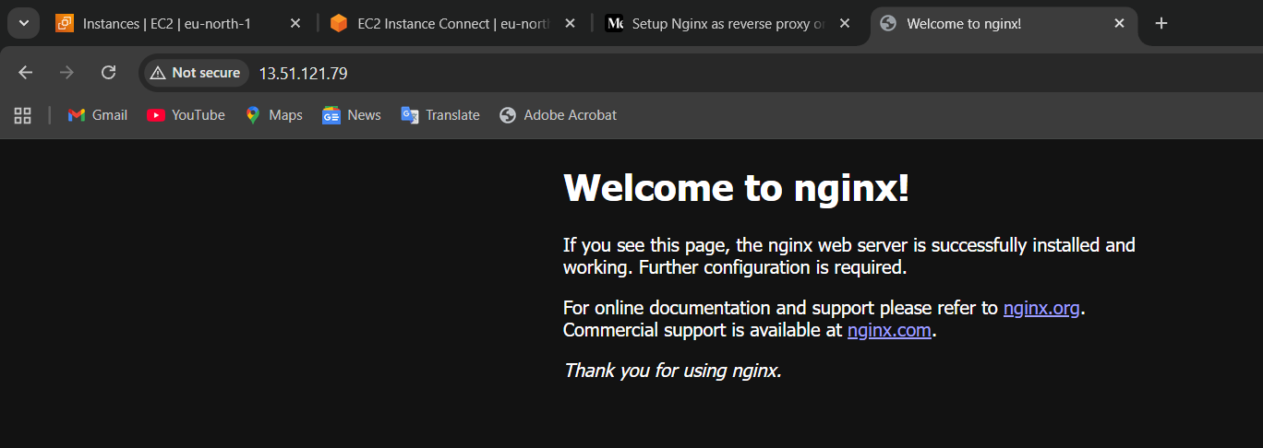

Change Nginx Port Number

sudo vi /etc/nginx/nginx.conf

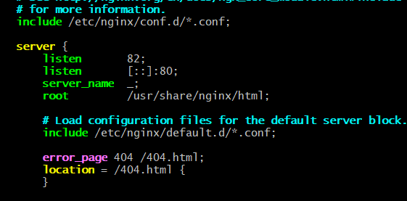

Change and save &exit

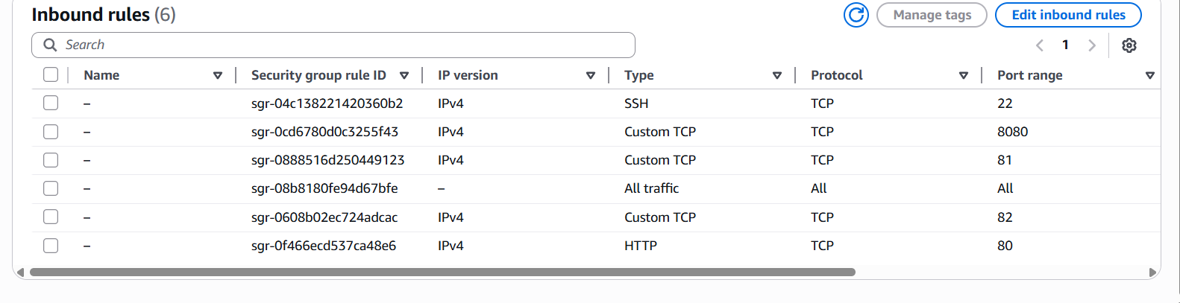

Netstat -na | grep (82) to check whether your port is running or not

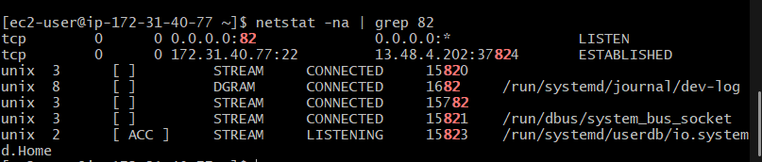

<http://13.51.121.79:82/> (ip:82) paste it webser

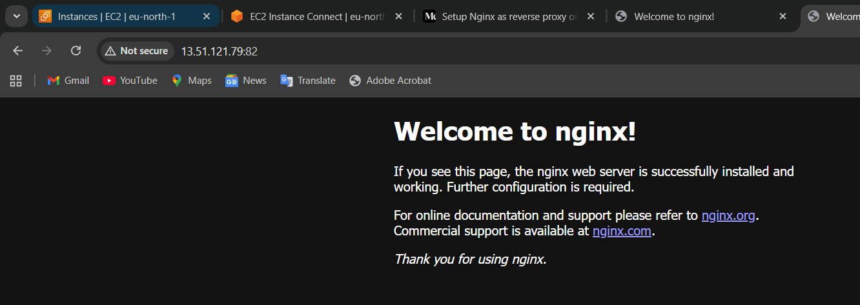

**5 ) Install Apache Tomcat.**

sudo yum update -y

Update System

Wget (link)

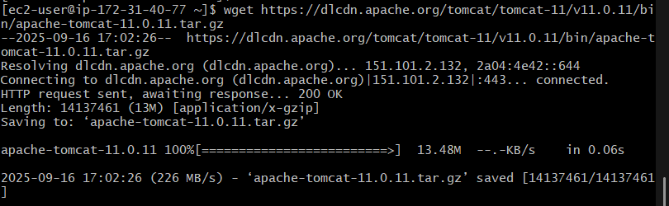

To extract and install downloaded Apache tomcat: Type **‘tar -zvxf’** and paste the blue highlighted command (Highlighted command should be on the screen of our device)



 Install java (Type:**yum install java -y**)

Install Java (Tomcat needs Java)

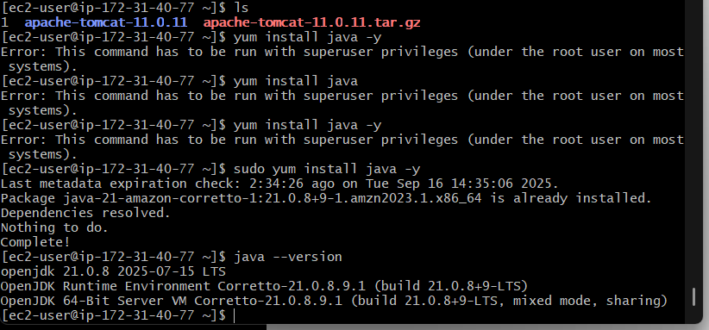

 we can find startup.sh (in green font) through **‘ls’** command

Go to the bin folder, which is in the Apache folder (Type: **cd bin**)

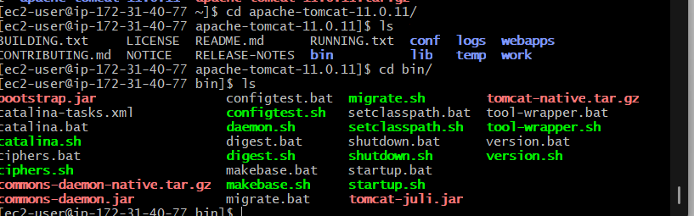

 Now type **‘./startup.sh’**to start tomcat

We can see the tomcat has been started

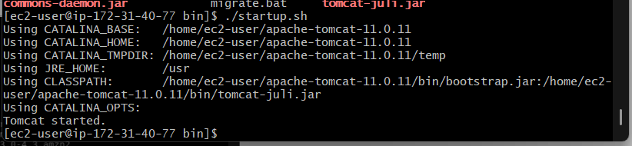

sudo vi /tomcat9/conf/server.xml

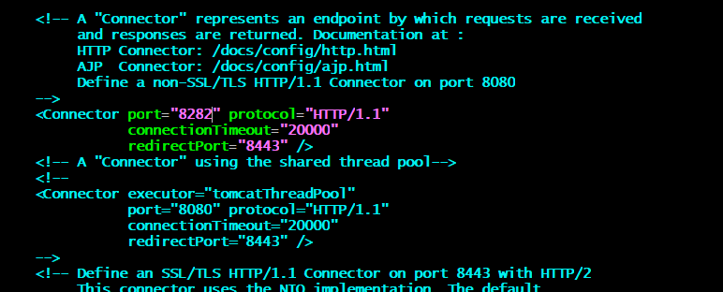

Come to the AWS console & Copy the public IP of the server and paste to browser

**Open Port in AWS Security Group**

Go to **EC2 → Security Groups → Inbound rules**

* Add rule:
  + **Type:** Custom TCP
  + **Port:** 8080 (or 9090 if changed)
  + **Source:** 0.0.0.0/0 (or just your IP for security)

sudo vi /opt/tomcat9/conf/server.xml

apache-tomcat-11.0.11=>conf>server.xml change, edit and save



cd /opt/tomcat9/bin

sudo ./shutdown.sh

sudo ./startup.sh

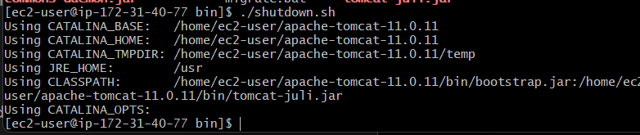

sudo ./startup.sh



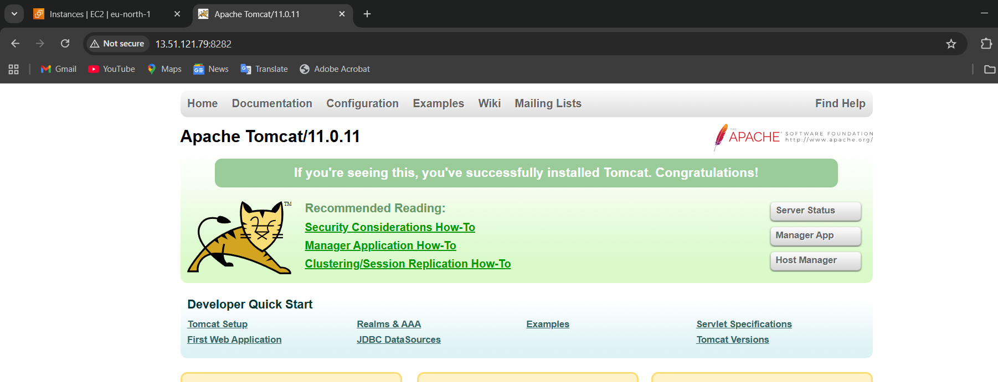

✅ Now Tomcat is installed, running, and serving requests.